H.T No
Regulations:
A18

Sreenidhi Institute of Science and Technology
(An Autonomous Institution)
Code No: 7K201 Date: 23-Nov-2020 (FN)

B.Tech I-Year II-Semester External Examination, Nov/Dec - 2020 (Regular & Supplementary)
ENGINEERING MECHANICS FOR CIVIL ENGINEERING (CIVIL)

Time: 2 Hours Max.Marks:70

Note: a) No additional answer sheets will be provided.
b) All sub-parts of a question must be answered at one place only, otherwise it will not be valued.
c) Missing data can be assumed suitably.

ANSWER ANY 5 OUT OF 8 QUESTIONS. EACH QUESTION CARRIES 14 MARKS.

1. | a) | Two equal weights each of 1000N is supported by a flexible string as shown in fig below. Find the tensions in the portion AB and CD of the string.  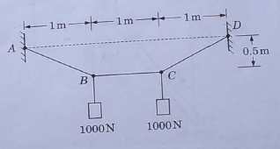 | [7M]
 | b) | Two forces P and Q are applied as shown in Fig. 1, to an aircraft connection. Knowing that the connection is in equilibrium and that P = 500 N and Q = 650 N, determine the magnitudes of the forces exerted on the rods A and B.  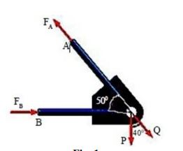 | [7M]
2. |  | A uniform ladder AB of length l=20 m and weight W is supported by the horizontal floor at A and by a vertical wall at B. It makes an angle 45⁰ with the horizontal. If a man, whose weight is one half that of the ladder, ascends the ladder, how much length x of the ladder he shall climb before the ladder slips. If a boy now stands on the end A, what must be his least weight w so that the man may go on the top of the ladder? Assume,µ between the ladder and the wall=1/3, µ between the ladder and the floor=1/2 | [14M]
3. |  | An I-section is made up of three rectangles as below Figure. Find the moment of inertia of the section.  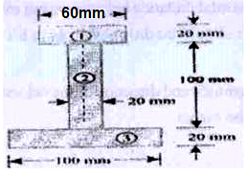 | [14M]
4. |  | Determine the Horizontal and vertical components of reactions at A and B of frame which made of three squares and three hinged as shown in below figure using virtual energy method.  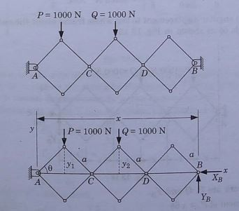 | [14M]
5. |  | A Projectile is fired with velocity of 500m/s at an inclination of 30⁰  - Find the velocity and Direction of Projectile after 30sec of travel.  - Determine the time of flight.  - Find out maximum height of projectile. | [14M]
6. | a) | A body moves along a straight line so that its displacement from a fixed point on the line is given by s = 3t2 + 2t. Find the displacement, velocity and acceleration at the end of t = 3s. | [7M]
 | b) | An open platform elevator is moving down a mine shaft with an acceleration 0.5 m/s^{2.} After the elevator has travelled 25m (from the top shaft) a stone dropped from the shaft determine a) the time taken the stone to hit the elevator the distance travelled by the elevator at the time of impact. | [7M]
7. |  | Three cylindersare piled up in a rectangular channel as shown in Figure below. Determine the reaction R₆ between the cyclinder A and the vertical wall of the channel.  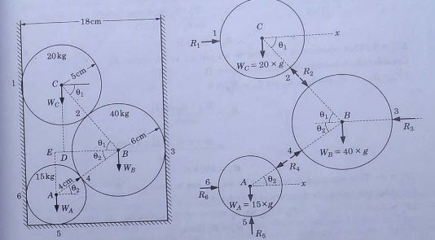 | [14M]
8. |  | A horizontal bar 1 m long and of negligible weight rests on rough inclined planes shown in below fig. If the angle of friction is 15⁰, determine the minimum value of x at which the load Q = 200N may be applied before slipping impends.  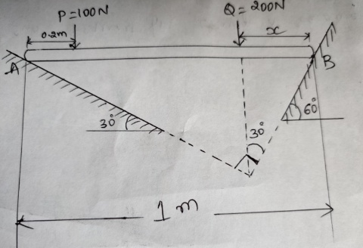 | [14M]

-- 00 -- 00 –

